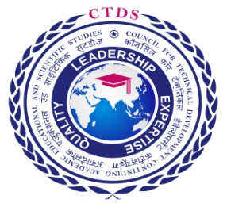

QCI - QUALITY COUNCIL OF INDIA

NIESBUD - NATIONAL INSTITUTE FOR ENTREEPRENEURSHIP AND SMALL

BUSINESS DEVELOPMENT

PMKVY - PRIME MINISTER KAUSHAL VIKAS YOJANA , UNDER

NSDC -NATIONAL SKILLS DEVOLPMENT CORPORATION

ACCREDITATION - DAC - DUBAI ACCREDITATION CENTRE

IAS -INTERNATIONAL ACCREDITATION SERVICE

IAF - INTERNATIONAL ACCREDITATION FORUM

